## PC Installation

1. Extract the Add-in folder (Fred) on to your computer. You should not move this folder after you install the Add-in.
2. Open Microsoft® Excel® and click on the *Office Button*  in the upper left-hand corner of the window.
3. Choose  from the drop down menu, a window will appear.
4. On the left side of the window choose *Add-ins.*
5. On the bottom of the window choose *Go.*  
6. In the new window, choose  and locate the file *fred.xlam* that you downloaded and click *OK.*
7. Make sure the check box next to FRED is checked: . Click *OK.*
8. You will be prompted with a security warning asking if you want to allow Macro’s and data connections from the Add-in. Click *OK.*
9. Close and re-open Excel to verify that the Add-in has been installed correctly.

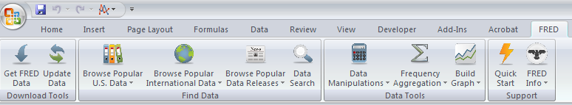

**Important Security Note:** You may need to change your Excel security settings to avoid the data connections warning each time you open Excel, you can do this two ways:

Option 1: Add the FRED folder as a “trusted location” (suggested).

1. Open Excel and click on the *Office Button*  in the upper left hand corner of the window.
2. Choose  from the drop down menu, a window will appear.
3. On the left side of the window choose *Trust Center.*
4. Click on .
5. Choose *Trusted Locations* from the menu on the left.
6. Click on *Add new location.*
7. Browse for the FRED folder and click *OK*.

Option 2: Enable all data connections.

1. Open Excel and click on the *Office Button*  in the upper left hand corner of the window.
2. Choose  from the drop down menu, a window will appear.
3. On the left side of the window choose *Trust Center.*
4. Click on .
5. Choose *External Content.*
6. Choose *Enable all Data Connections* under the Security settings for Data Connections.